Sentiment Analysis of Public Tweets using Stemming
Kent Roller

Introduction
Text data is an invaluable source of information for companies looking to gain insight into public perception about their latest products, services, or gauging the climate for integrating new technology into existing products and services. Due to its unstructured form factor however, properly utilizing this information has been prohibitive in both cost and computational power available. Within the past two decades, text information and unstructured data at large has rapidly transformed from a novelty to a priceless asset. Many times, this information can be used to glean information not readily apparent, which can lead to a first-mover advantage in an underserved market which can result in a very real boon for the company. In order to make sense of the large amount of information text data presents, sentiment analysis can be used to “score” the target text data. This scoring varies by method used. Once the text has been scored a label can be applied, and sentiment information can be gathered from either the score itself or the label which is dependent on the value of the score. Using this approach, large amounts of data can be quickly and succinctly summarized to be able to gain powerful insights at a glance.

Method
The data used is the same data used previously in the analysis of online tools. The data is a collection of tweets collected around the time that ChatGPT made its public release. All of the tweets pertain to ChatGPT and as such can be used to learn about the public sentiment regarding the technology at the time of its release. The dataset was found on Kaggle[1] and did not contain a large amount of pre processing. The data was encoded using the ISO-8859-1 protocol, as such, any attempts to load in the data should be paired with the encoding argument in the read statement. Once the data was successfully imported, there were still issues present in regards to the character identification. To circumnavigate this, a REGEX command was used in an attempt to remove all non alpha numeric characters from the text file. After this the data was pre-processed in a manner sufficient enough to allow for the use of sentiment analysis tools. Stop words were used in the sentiment analysis, specifically the NLTK provided ‘punkt’ and ‘stopwords’ were used. During the tokenization process, the words were converted to lower case and then the stopwords were used to filter out the words being tokenized. The stop words being implemented at a different stage in the process may yield different results from the ones found here. Vader and NLTK sentiment analysis were performed on the text after being tokenized and having the stopwords removed. It should be noted that both Count Vectorizer and TfIdf vectorizers were used but the use of these did not result in different dataframe shapes. That is, after applying one method or the other, the shape of the vectorized dataframe was the same at (975452, 321586). However, applying the TfIdf vectorizer to the stemmed text data resulted in a shape of (975452, 284632). While not the drastic reduction that was hoped for, this is still a removal of around ~40,000 observations. After sentiment analysis was performed on the text data using the Vader and NLTK sentiment analysis tools, we then went back and applied the stemming to the text data. This boils the text data down to its root word, and here the NLTK included PorterStemmer was used. There was no comparison of Stemmers performed at this time. After stemming was applied to the text data the sentiment analysis of each text type was compared, which will be explored further in the results section.

Results
For each of the of the methods used, sentiment analysis was performed, and then each method was compared to the other. That is, sentiment analysis was performed with NLTK and Vader sentiment analysis tools first. Then labels were applied to these scores. After this, stemming was applied to the cleaned_text column which was used for the sentiment analysis. After stemming, the methods were applied again, using both NLTK and Vader sentiment analysis, but this time on the stemmed text data instead of the cleaned_text that was used previously. These methods were compared to see how the stemming affects the scoring during this analysis.
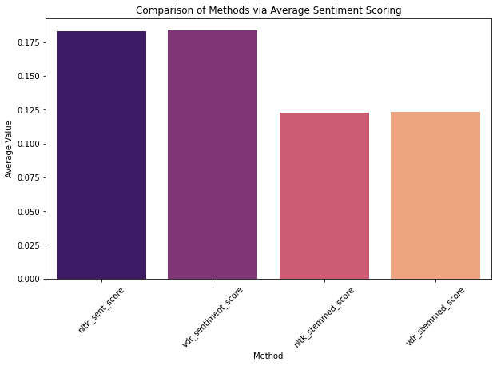
Fig 1.1 Comparison of average value across methods
In Figure 1.1 the comparison between average scores for each of the methods can be observed. Here, the NLTK sentiment analysis is shown first, with the second highest value. The Vader sentiment analysis is next with the highest value of all the methods shown. The next two values are the stemmed versions of the text, with NLTK analysis of the stemmed text being the lowest of all methods, and Vader being applied on the stemmed text results in the second lowest value. It should be noted that while the values do vary, the variation is rather small between each method. It should also be noted that each of the methods used resulted in a positive outcome. The sentiment for each method, on average, is positive. This suggests that overall, the public sentiment towards ChatGPT is positive. It should be noted that the positive values are not very high, but they are positive none the less. From this we can conclude that the overall sentiment towards the tech based on the twitter data is indeed positive, though if the company is rather public facing and the integration is not a hard requirement for the business then it may be worth holding off of the integration until public perception increases. Next we compare the labeling of each of the methods to see at what frequency the labels were applied to each of the tweets in the database.

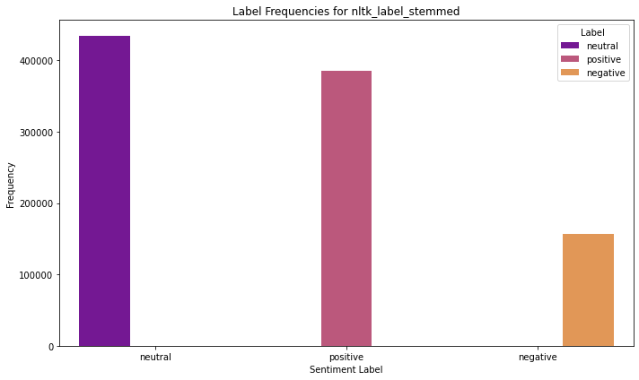
Fig 1.2 Frequency count of stemmed NLTK analysis
In Figure 1.2 the frequency count of labels for the NLTK stemmed sentiment analysis can be seen. Here the neutral count is the highest value of all labels with around 430,000 observations being neutral. Positive is a close second with around 400,000 observations. Negative tweets labels have the lowest count at around 180,000. For comparison, we next look at how stemming affected the NLTK sentiment analysis by checking the non stemmed values.
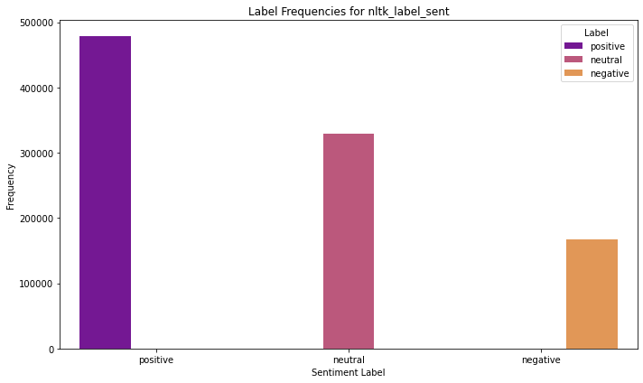
Fig 1.3 Frequency counts of non-stemmed NLTK analysis
In figure 1.3 the frequency counts of the non-stemmed NLTK sentiment analysis can be observed. Here we can see the positive count is much higher when compared to the stemmed values with a count of around 500,000 observations being counted as positive. Neutral labels are second in the sentiment analysis without stemmed labels with around 360,000 observations. Negative labels are still the lowest frequency regardless of stemming, with a similar count of around 180,000 observations. It should be noted that different stemming methods may result in different outcomes here, as other stemming methods may be more effective at capturing or reflecting the sentiment displayed in the analysis of the non stemmed text. It should also be noted that no method of checking the accuracy of these methods has been deployed, so which method is more in line with the absolute truth is not known or meant to be inferred from this information.

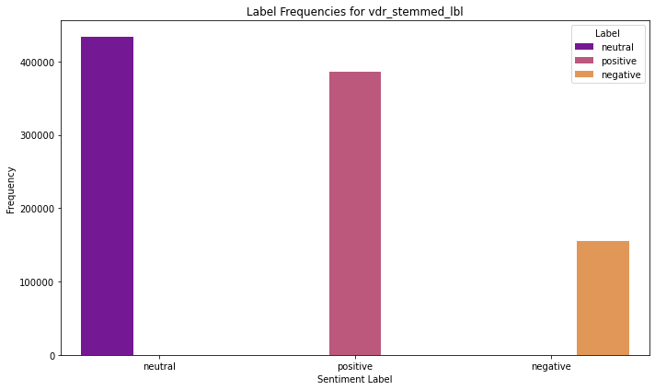
Fig 1.3 Frequency counts of Stemmed Vader Analysis
In Figure 1.3, the frequency of counts of the stemmed Vader sentiment analysis can be observed. Like the stemmed NLTK sentiment analysis, the Vader sentiment analysis using the stemmed text also places neutral labels with the highest frequency counts. Here the count is around 400,000, very similar to what was observed with the NLTK analysis. Likewise, the positive label frequency is also similar around 380,000. And negative labels are once again the same as the negative frequency counts. Overall, the outcome of the analysis using Vader with the stemmed text is very similar to that of the NLTK stemmed analysis. Next we can compare that to the non-stemmed Vader analysis.

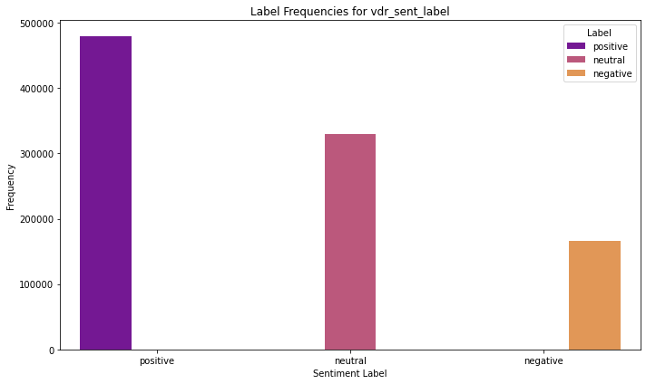
Fig 1.4 Frequency counts of non-stemmed Vader Analysis
In figure 1.4 the frequency counts of the non-stemmed Vader Analysis can be observed. Here, like with the non-stemmed NLTK analysis, the positive and the neutral labels are switched in the non-stemmed Vader analysis. We also see what appear to be fairly close values to the non-stemmed NLTK analysis for each of the observations.

Results
Sentiment analysis is a powerful tool that allows for the extraction of public opinion from various text sources. Using data from social media or other such outlets is only one use of sentiment analysis, as many forms of text can be investigated with these tools. Companies are often interested in public opinion to keep their customers happy and interested in the companies products and services. In order to make these data sources ready for ingestion by machine learning algorithms, certain steps may be taken such as stemming and vectorization. Here we compared the results of the sentiment analysis between the non-stemmed and stemmed text data to see how these modifications can potentially affect the outcome of the analysis. In both cases, reducing the words to their root, or stemming, resulted in the majority of the text being considered as having a neutral sentiment. Interestingly, when using the non-stemmed data, positive became the highest ranked label frequency. As stated previously, it should be noted that no measurement of accuracy between methods has been used to determine which is closer to any absolute truth that may exist within the data. Choosing between methods will be dependent on user requirements.

References
[1] https://www.kaggle.com/datasets/infsceps/chatgpt-tweets/data

